## A white circle with blue and orange text Description automatically generatedK.S.RANGASAMY COLLEGE OF TECHNOLOGY

(Autonomous)

## TIRUCHENGODE – 637 215

**A CASE STUDY REPORT**

# Education Equity and Access

## Submitted by

|  |  |
| --- | --- |
| **DHARSHINI G** | **(73772227109)** |

**DINESHKARTHICK SS (73772227110)**

***in partial fulfillment of the requirementfor the award of the degree***

***of***

## BACHELOR OF TECHNOLOGY

***in***

## COMPUTER SCIENCE AND BUSINESS SYSTEMS K.S.RANGASAMY COLLEGE OF TECHNOLOGY

(An Autonomous Institution, affiliated to Anna University Chennai and Approved by AICTE, New Delhi)

**TIRUCHENGODE – 637 215**

# K.S.RANGASAMY COLLEGE OF TECHNOLOGY, TIRUCHENGODE -637215

### (Autonomous Institution)



Certified that this is the bonafide record of work done by Selvan/Selvi

**DHARSHINI G (73772227109)** and **DINESH KARTHICK SS(73772227110)**

of the Fourth Semester B.Tech Computer Science and Business Systems branch during the academic year 2023-2024 in the Universal Human Values Case Study.

#### Staff in-charge Head of the Department

Submitted for the End Semester Practical Examination on …………………….

# Internal Examiner

**TABLE OF CONTENTS**

Abstract 01

Introduction 02

Example 1 03

Example 2 04

Example 3 05

Example 4 06

Example 5 07

Example 6 08

Example 7 09

Example 8 10

Example 9 11

Example 10 12

Tree Plantation 13

Conclusion & Reference 14

# Case Study on Education Equity and Access

# Abstract

Educational equity remains a critical issue worldwide, as disparities in access to quality education continue to disadvantage marginalized groups. This report investigates these inequities through ten diverse case studies, revealing the complex interplay of socioeconomic, racial, gender, and linguistic barriers. We explore how rural-urban divides, socioeconomic status, racial and ethnic backgrounds, gender norms, and special educational needs contribute to unequal educational opportunities. Additionally, we examine the challenges faced by non-native speakers, refugee and immigrant students, LGBTQ+ students, and indigenous communities. By utilizing real-time data analysis and implementing initiatives like tree plantation programs in schools, this report offers a comprehensive overview and actionable strategies to bridge these gaps. Our goal is to advocate for a more inclusive educational landscape where every student has the opportunity to succeed, regardless of their background or circumstances..

# Introduction

Educational equity is the foundation for ensuring that all students, regardless of their backgrounds, have access to the resources and opportunities necessary for their academic and personal success. Despite significant progress in global education, deep-rooted disparities persist, disproportionately affecting marginalized groups and perpetuating cycles of inequality. These disparities can manifest in various forms, including differences in school funding, quality of teaching, availability of advanced coursework, and access to extracurricular activities.

The pursuit of educational equity involves addressing systemic barriers that impede the educational experiences of students from diverse backgrounds. These barriers often intersect, creating complex challenges that require multifaceted solutions. For instance, socioeconomic status, race, ethnicity, gender, language, disability, and geographic location can all influence a student's educational journey. Each of these factors can compound, making it difficult for affected students to achieve their full potential.

This report aims to shed light on the multifaceted nature of educational inequity by presenting a series of case studies from different contexts. By examining specific examples of how disparities manifest in various settings, we can gain a deeper understanding of the root causes and identify effective strategies for promoting inclusive education. The report also emphasizes the importance of real-time data analysis and innovative initiatives, such as tree plantation programs, to enhance the educational environment and foster a holistic learning experience.

# Example 1: Urban vs. Rural Schools

#### Context

In the United States, significant disparities exist between urban and rural schools due to funding differences tied to local property taxes. Urban schools often have better infrastructure, more qualified teachers, and greater access to resources, while rural schools frequently struggle with inadequate facilities, teacher shortages, and limited academic and extracurricular opportunities.

#### Initiatives

* **Equitable Funding Policies**: Reforming funding formulas to allocate state funds based on student needs rather than local property taxes.
* **Teacher Incentive Programs**: Providing loan forgiveness, housing subsidies, and higher salaries to attract and retain qualified teachers in rural areas.
* **Infrastructure Improvements**: Allocating federal and state grants to renovate and modernize rural school facilities.
* **Technology Integration**: Programs like the FCC's E-Rate to provide affordable internet access and broadband infrastructure to rural schools.

#### Outcomes

* **Improved Academic Achievement**: Increased test scores and graduation rates in schools benefiting from equitable funding and infrastructure improvements.
* **Enhanced Teacher Retention**: Better retention rates and higher quality education due to teacher incentive programs.
* **Increased Access to Technology**: Improved digital learning and continuity in education through enhanced internet connectivity.

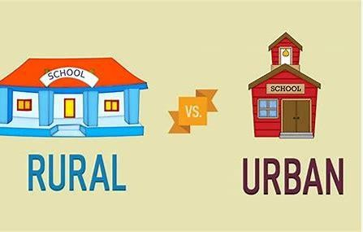

# Example 2: Socioeconomic Barriers

#### Context

Students from low-income families face significant obstacles in accessing quality education, including inadequate school funding, lack of access to early childhood education, and insufficient support services.

#### Initiatives

* **Free School Meal Programs**: Providing nutritious meals to ensure students are well-fed and ready to learn.
* **Scholarship and Financial Aid Programs**: Offering scholarships and financial aid to cover educational expenses for low-income students.
* **Community Schools**: Establishing schools that provide wraparound services such as healthcare, counseling, and after-school programs.

#### Outcomes

* **Improved Attendance and Performance**: Better attendance rates and academic performance due to increased access to nutrition and support services.
* **Higher Graduation Rates**: Increased graduation rates as financial barriers to education are reduced.
* **Enhanced Student Well-being**: Improved physical and mental health through access to comprehensive support services.



# Example 3: Racial and Ethnic Disparities

#### Context

Racial and ethnic minorities often face inequities in education, including attending under- resourced schools and facing disciplinary actions that disproportionately affect their educational outcomes.

#### Initiatives

* **Culturally Responsive Teaching**: Training teachers to incorporate culturally relevant pedagogy in the classroom.
* **Anti-Bias Training**: Implementing training programs for educators to reduce implicit bias and promote inclusive practices.
* **Equitable Resource Allocation**: Directing additional resources and support to schools with high percentages of minority students.

#### Outcomes

* **Reduced Achievement Gaps**: Narrowing academic performance gaps between minority and non-minority students.
* **Decreased Disciplinary Disparities**: Lower rates of disciplinary actions against minority students.
* **Enhanced Cultural Competence**: Improved cultural awareness and sensitivity among educators and students.

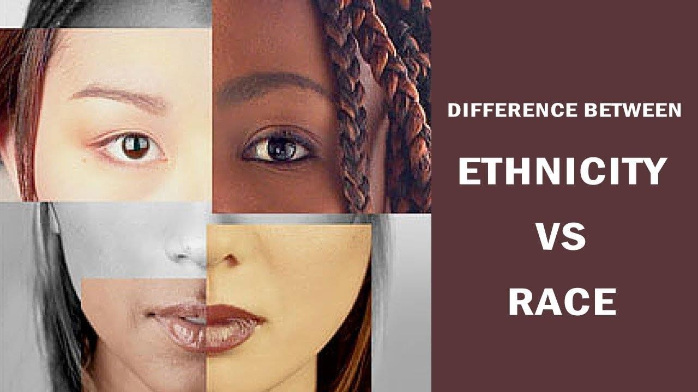

# Example 4: Gender Inequality

#### Context

In many parts of the world, girls face significant barriers to education due to cultural norms, safety concerns, and economic factors.

#### Initiatives

* **Girls' Scholarship Programs**: Providing scholarships specifically for girls to encourage their enrollment and retention in school.
* **Safe School Environments**: Implementing measures to ensure schools are safe for girls, including safe transportation and secure facilities.
* **Community Awareness Campaigns**: Raising awareness about the importance of girls' education through community outreach and engagement.

#### Outcomes

* **Increased Enrollment Rates**: Higher enrollment and retention rates of girls in schools.
* **Improved Academic Performance**: Better academic performance and graduation rates for girls.
* **Greater Community Support**: Increased community support for girls' education and gender equality.



# Example 5: Special Education Needs

#### Context

Students with disabilities often struggle to receive appropriate education due to a lack of resources, trained staff, and inclusive practices.

#### Initiatives

* **Inclusive Education Policies**: Enforcing policies that mandate inclusive education practices in all schools.
* **Specialized Training for Teachers**: Providing professional development for teachers to support students with disabilities effectively.
* **Assistive Technology**: Supplying schools with assistive technology to help students with disabilities access the curriculum.

##### Outcomes

* **Enhanced Learning Outcomes**: Improved academic performance and engagement of students with disabilities.
* **Better Teacher Preparedness**: Increased teacher confidence and capability in supporting diverse learners.
* **Inclusive School Environments**: More inclusive and supportive school environments for all students.

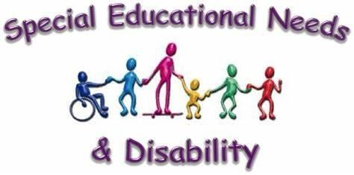

# Example 6: Language Barriers

#### Context

Non-native speakers frequently face challenges in accessing education due to language barriers, leading to lower academic performance and higher dropout rates.

#### Initiatives

* **Bilingual Education Programs**: Implementing programs that teach in both the native language and the second language.
* **Language Support Services**: Providing additional language support through tutoring and language acquisition classes.
* **Cultural Integration Programs**: Offering programs that promote cultural integration and understanding within the school community.

#### Outcomes

* **Improved Language Proficiency**: Enhanced language skills and academic performance of non- native speakers.
* **Higher Retention Rates**: Increased retention and graduation rates for students facing language barriers.
* **Greater Cultural Integration**: Improved cultural understanding and inclusivity within the school community.

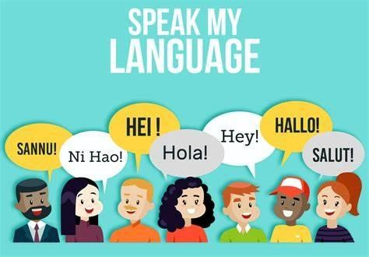

**Example 7: Refugee and Immigrant Students**

#### Context

Refugee and immigrant students often encounter unique challenges, such as cultural adjustment, language barriers, and trauma from displacement.

#### Initiatives

* **Welcome Centers**: Establishing centers that provide orientation and support services for newly arrived students.
* **Trauma-Informed Education**: Training educators to recognize and support students dealing with trauma.
* **Community Partnerships**: Collaborating with local organizations to provide comprehensive support services for refugee and immigrant families.

#### Outcomes

* **Successful Integration**: Better cultural and social integration of refugee and immigrant students.
* **Enhanced Academic Support**: Improved academic performance and engagement through targeted support services.
* **Stronger Community Ties**: Strengthened community relationships and support networks for refugee and immigrant families.

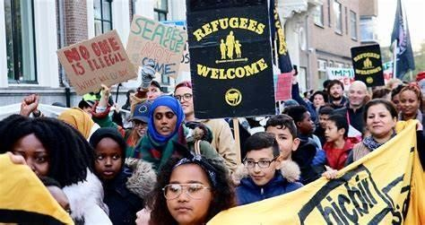

# Example 8: LGBTQ+ Students

#### Context

LGBTQ+ students may face discrimination, bullying, and a lack of support in educational settings, affecting their well-being and academic success.

#### Initiatives

* **Safe Space Programs**: Creating safe spaces and support groups for LGBTQ+ students within schools.
* **Anti-Bullying Policies**: Implementing and enforcing strict anti-bullying policies to protect LGBTQ+ students.
* **Inclusive Curriculum**: Developing curricula that include and respect LGBTQ+ identities and issues.

#### Outcomes

* **Improved Mental Health**: Enhanced well-being and mental health of LGBTQ+ students.
* **Better Academic Performance**: Increased engagement and academic performance of LGBTQ+ students.
* **Inclusive School Culture**: More inclusive and accepting school environments for all students.

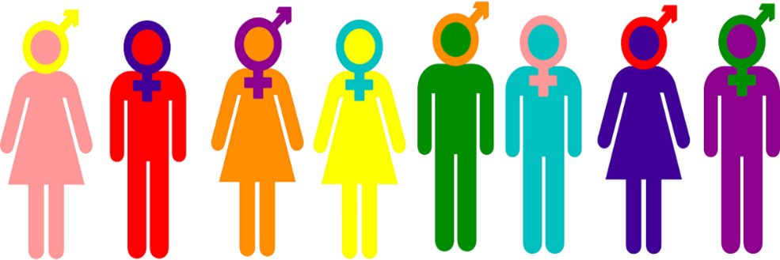

# Example 9: Indigenous Communities

#### Context

Indigenous students often face educational disparities due to historical marginalization, cultural disconnection, and inadequate funding.

##### Initiatives

* **Culturally Relevant Curriculum**: Incorporating indigenous knowledge, languages, and cultural practices into the school curriculum.
* **Community Involvement**: Engaging indigenous communities in the education process and decision-making.
* **Targeted Funding**: Allocating funds specifically for the development and support of indigenous education programs.

##### Outcomes

* **Cultural Preservation**: Strengthened cultural identity and preservation among indigenous students.
* **Improved Educational Outcomes**: Higher academic achievement and engagement of indigenous students.
* **Empowered Communities**: Greater community involvement and empowerment through education.

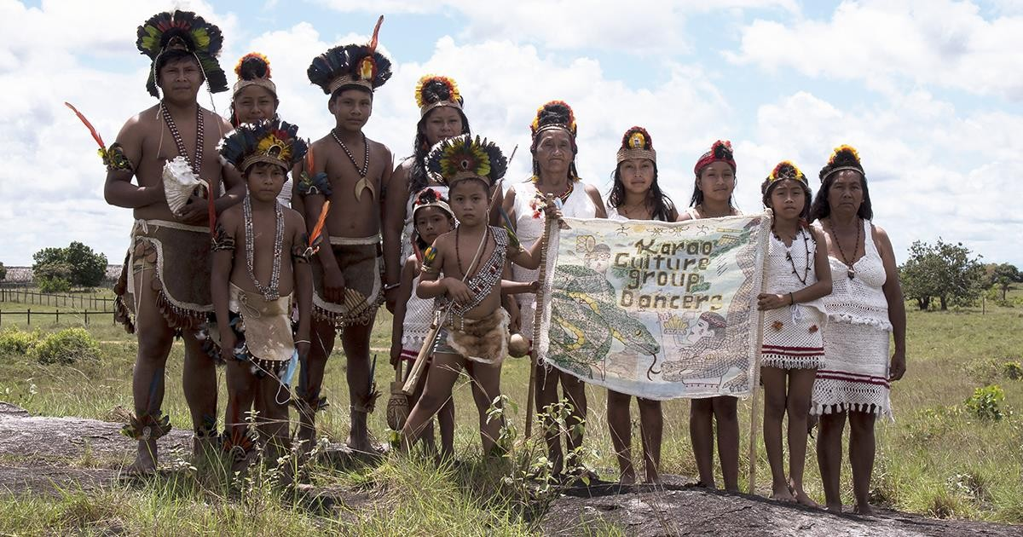

# Example 10 : Technology Access

#### Context

The digital divide exacerbates educational inequities, especially in remote and low-income areas, where students may lack access to technology and internet connectivity.

#### Initiatives

* **Device Distribution Programs**: Providing laptops, tablets, and other digital devices to students in need.
* **Internet Access Initiatives**: Partnering with internet service providers to offer affordable or free internet access to low-income families.
* **Digital Literacy Training**: Offering training programs to enhance digital literacy for students, teachers, and parents.

#### Outcomes

* **Bridged Digital Divide**: Reduced disparities in technology access between students from different socioeconomic backgrounds.
* **Enhanced Learning Opportunities**: Improved academic performance and engagement through access to digital resources and online learning.
* **Increased Digital Literacy**: Greater digital literacy and preparedness for the future workforce.

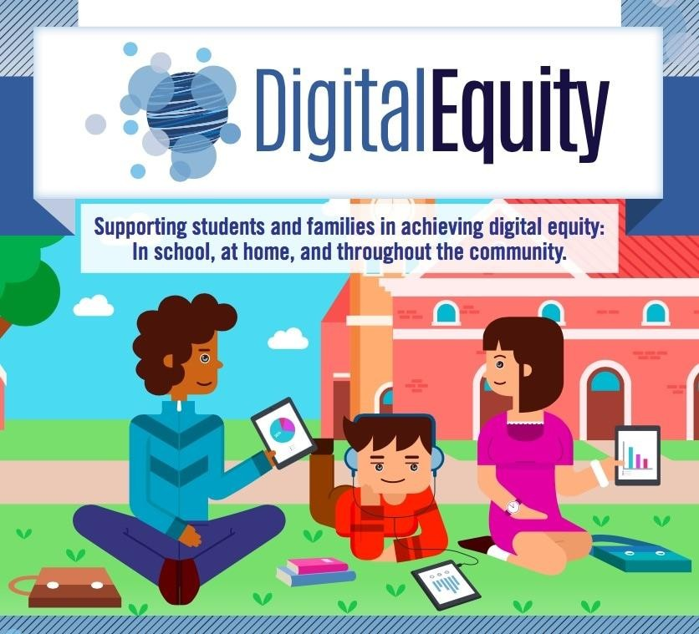

**TREE PLANTATION:**



**CONCLUSION:**

### Addressing educational inequities requires a comprehensive approach involving equitable funding, support for teachers, inclusive practices, technology access, community engagement, and holistic support systems. By reforming funding mechanisms, providing incentives and training for teachers, implementing inclusive policies, bridging the digital divide, and engaging communities, we can significantly improve educational outcomes for marginalized groups. Holistic support, including nutrition and mental health services, enhances student well-being and academic performance. Learning from diverse case studies and implementing evidence-based strategies can create a more equitable and inclusive education system, ensuring every student has the opportunity to succeed, regardless of their background.

**REFERENCE:**

[Department of Education Equity Action Plan | U.S. Department of Education](https://www.ed.gov/equity)

[E-Rate: Universal Service Program for Schools and Libraries | Federal Communications Commission](https://www.fcc.gov/consumers/guides/universal-service-program-schools-and-libraries-e-rate) [(fcc.gov)](https://www.fcc.gov/consumers/guides/universal-service-program-schools-and-libraries-e-rate)

unesdoc.unesco.org/ark:/48223/pf0000373724